A Law Library of Louisiana FREE CLE
Co-sponsored by the Supreme Court of Louisiana Historical Society, the Plessy and Ferguson Foundation, and the UNO Earl K. Long Library

MADAME JOSEPHINE DECUIR AND THE JOURNEY
TO SEPARATE BUT EQUAL

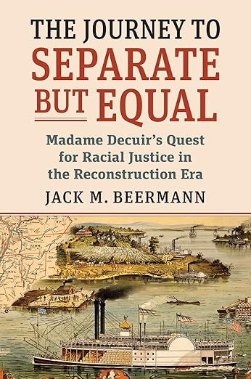

Presented by Professor Jack M. Beermann
Monday, May 18 ♦ 5:00 p.m – 6:00 p.m.
UNO Earl K. Long Library, 4th Floor
- Lakeshore Avenue, New Orleans, LA

- Hour CLE credit

The main focus of the lecture will be on the case of Hall v. Decuir, 95 U.S. 485 (1877), in which the United States Supreme Court decided that Louisiana could not apply its anti-discrimination law to conduct on a riverboat on the Mississippi River due to federal legal control over interstate navigable waters. The plaintiff in the case was Madame Josephine Dubuclet Decuir, widow of planter Antoine Decuir of Point Coupée Parish and sister of one-time Louisiana State Treasurer and planter Antoine Dubuclet. The lecture will also explore the legal and social background of the litigation, including Louisiana's post-Civil War anti-discrimination laws, the decisions of the Louisiana trial and Supreme Courts, the social status of the Gens de Couleur, and the backgrounds and careers of the lawyers who worked on the case, including Seymour Snaer, one of the first lawyers of color to practice in Louisiana.

Speakers

Professor Jack M. Beermann, Philip S. Beck Professor of Law at Boston University School of Law, is the author of the book The Journey to Separate but Equal: Madame Decuir's Quest for Racial Justice in the Reconstruction Era (Kansas. U. Press 2020). Professor Beermann has been on the faculty of Boston University School of Law since 1984, where he teaches Civil Rights Litigation, Administrative Law, Constitutional Law, and Supreme Court Decisionmaking. He has authored or co-authored four books on Administrative Law and has published widely in law reviews in the United States as well as in China and Germany. Professor Beermann has taught in China, Germany, and Israel as well as Harvard Law School in Massachusetts and DePaul Law School in Illinois. His most recent book is Chief Justice Abraham Lincoln and the End of Reconstruction, a fictional account of a Supreme Court presided over by Abraham Lincoln after President Lincoln served two full terms as President.

