A Law Library of Louisiana FREE CLE
Co-sponsored by the Supreme Court of Louisiana Historical Society

Writ NOT Denied: Navigating the Louisiana Supreme Court’s Rule X

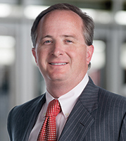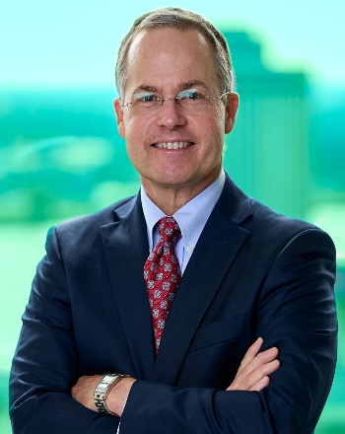

Presented by Isaac H. Ryan, Esq. & Thomas M. Flanagan, Esq.
Thursday, November 20 ♦ 10:00 a.m. – 12:15 p.m.
Louisiana Supreme Court Courtroom
- Royal Street, 4th Floor, New Orleans, LA

Agenda: 10:00-11:00 – Writ application panel discussion
11:00-11:15 – break
11:15-12:15 – Louisiana Supreme Court developments and professionalism in appellate practice

2.0 Hour Professionalism & Appellate Practice CLE credit

This program will educate attorneys about the particular function of the Louisiana Supreme Court as a court of public policy. Attorneys will be directed to the Rule X considerations listed by the Supreme Court and shown how to draft a meaningful Rule X analysis that focuses on the policy considerations that are important to Louisiana as a whole. There will be additional discussions of the noteworthy developments in the Court’s opinions for the past year and professionalism with regards to appellate practice.

Speakers

Isaac H. Ryan, Esq. is a former Supreme Court law clerk. Thomas M. Flanagan, Esq. is a former U.S. Fifth Circuit law clerk. Both have decades of experience as appellate and litigation attorneys. Mr. Flanagan is a fellow of the American Academy of Appellate Lawyers and the Past-President of the Bar Association of the Fifth Federal Circuit. Both have been named “Appellate Lawyer of the Year” by U.S. News.

